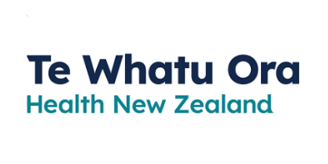
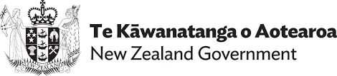
Making Your Water Safe
TN: There are two logos at the top of the page. On the left is: Te Kāwanatanga o Aotearoa New Zealand Government. On the right is: Te Whatu Ora Health New Zealand.
Adapted in 2023 by Accessible Formats Service, Blind Low Vision NZ, Auckland

Making Your Water Safe

The pipes that bring water to your home could be damaged. Use this information to know how to treat your water in an emergency.
Make sure you listen to the radio or visit local council website or Facebook for important information.
If water is coming out of your taps, check to see if your council has issued a boil water notice as damaged pipes may have contaminated the water supply.
If in doubt, always boil the water or drink stored water provided it hasn't expired.
If your bottled water has expired or you don't know how long it's been stored for, boil it before use.

Boil Water Instructions
Boil the kettle or jug until it turns off automatically or bring the water to a rolling boil for one minute, using a pot on the stove, BBQ, or portable cooker.
This boiled water can be used for:
- Drinking
- Food preparation
- Making infant formula
- Cleaning teeth
- Washing hands
- Your pets

If you can not boil water, you can use plain unscented household bleach to treat it for drinking and cleaning purposes.
- For drinking water: use ½ teaspoon bleach per 10 litres of water, or add 5 drops bleach to 1 litre of water.
- For cleaning water:
- General (dishes): use 1 teaspoon bleach per 1 litre water, or ¼ cup of bleach per 10 litres of water.
- Contaminated surfaces (toilets, illness)—¼ cup bleach per 1 litre water or 2 cups bleach per 10 litres water.
If water is not coming out of your taps, use any stored water such as bottled water, water tank, or from undamaged hot water cylinders. Follow the instructions above to boil or use bleach to treat it.

If you do not have any stored water, here are some other options for getting water:
- Neighbours/family/friends
- Purchase bottled water
- Collect and treat rainwater
- Talk with your Community Emergency Hub
From day 8 and onwards, check for community water collection points
Remember to keep listening to your radio for instructions, information and advice.
End of Making Your Water Safe

