
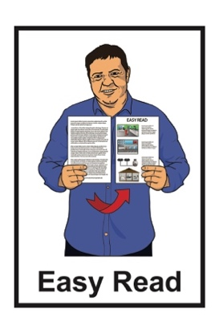

What to do if you test positive for COVID-19
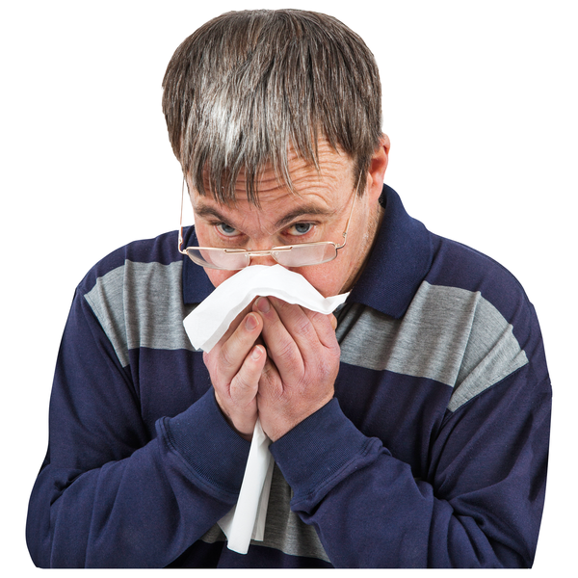
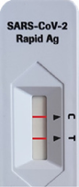


Updated: December 2023

Before you start

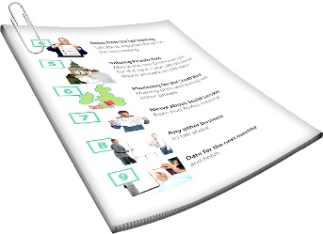
This is a long document.

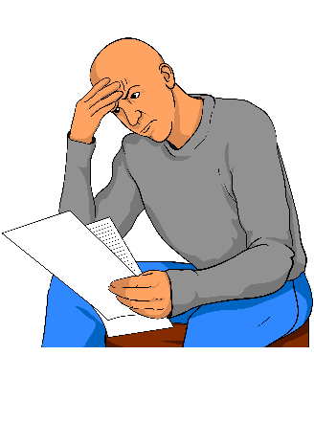
It can be hard for some people to read a document this long.

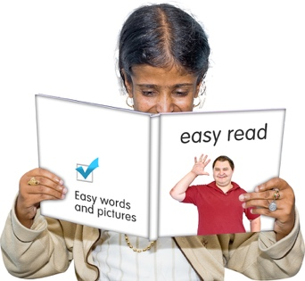
Some things you can do to make it easier are:
read it a few pages at a time
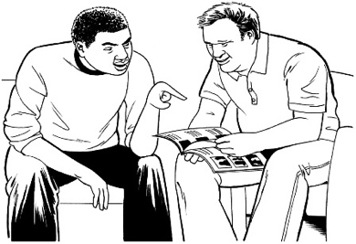
set aside some quiet time to look at it
have someone read it with you to support you to understand it.

What you will find in this document

Page number:
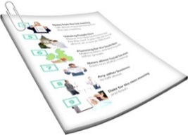

About this document 4

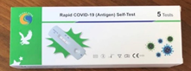
Testing for COVID-19 5

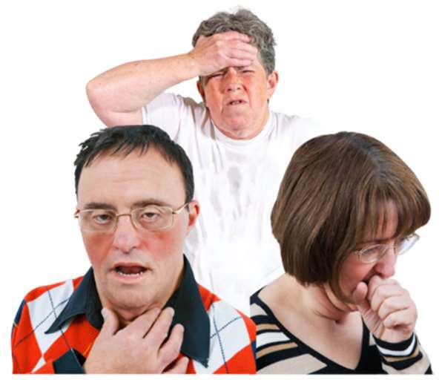
What to do if you have COVID-19 11

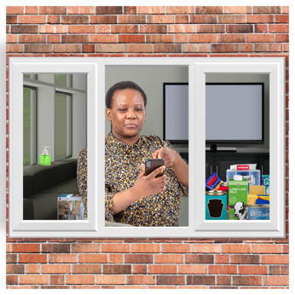
How to isolate 14

Isolating with tamariki / children 20

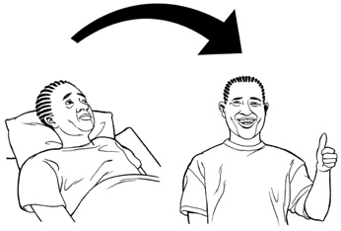
Leaving isolation 22

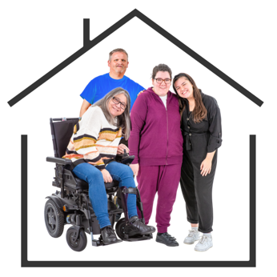
Page number:

If you are a household contact 24

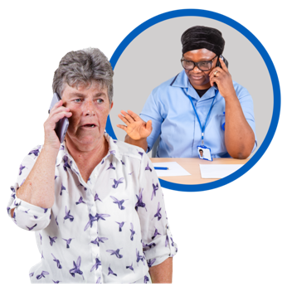
Where to get support 28

Where to find more information 31

About this document
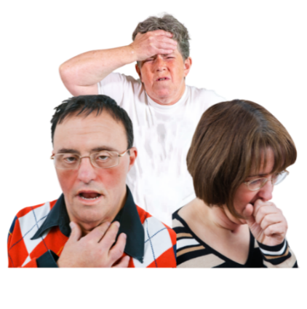

This document is about what to do if you test positive for COVID-19.

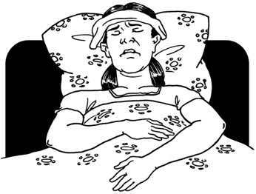
COVID-19 is a virus that can make people very ill.

A COVID-19 test can tell you if you have COVID-19.

If the test is positive that means you have COVID-19.

Testing for COVID-19

You should do a COVID-19 test if you have symptoms of:
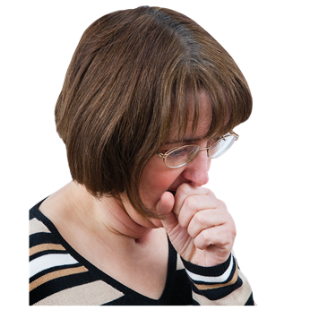
COVID-19
a cold
the flu.
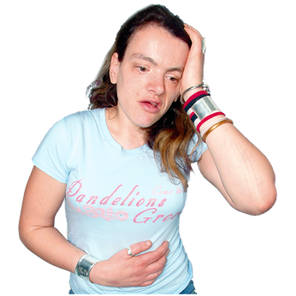

Symptoms means signs that you may have an illness.

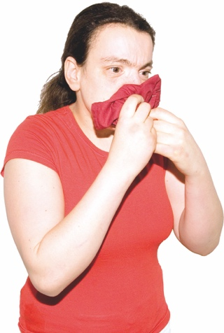
COVID-19 symptoms include things like:
a cough
sneezing and a runny nose
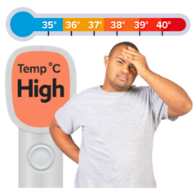
finding it hard to breathe.
high temperature of at least 38°C on a thermometer – this is when you would feel very hot
a sore throat
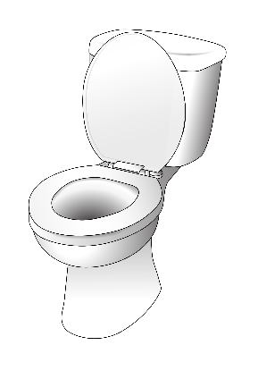
not being able to smell things for a little while
diarrhoea / runny poo
nausea / vomiting

Other COVID-19 symptoms are:
headache
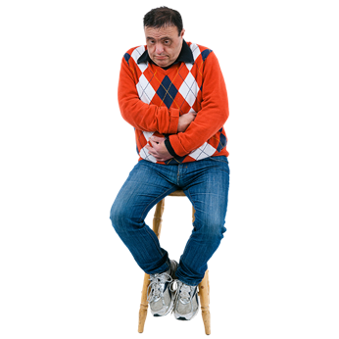
muscle pain or body aches
malaise — a general feeling of being unwell.

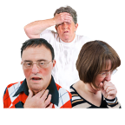
All these symptoms:
do not always mean you have COVID-19
can be symptoms of other illnesses like a cold or flu.

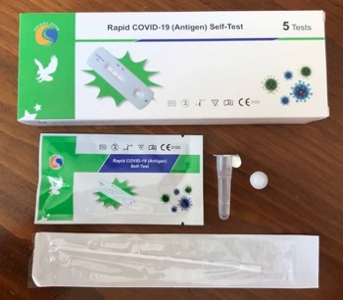
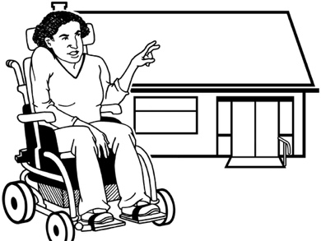
Most COVID-19 tests are RATs.

A RAT is a COVID-19 test you can do at home.

RATs are also called rapid antigen tests.

You can get RATs from:
COVID-19 testing centres
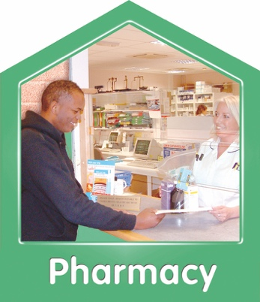
RAT collection sites
some pharmacies / chemists
some doctors.

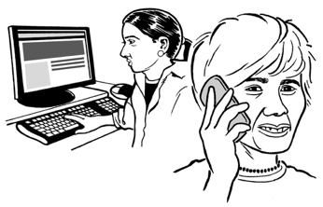
After you do a RAT you should report the result.

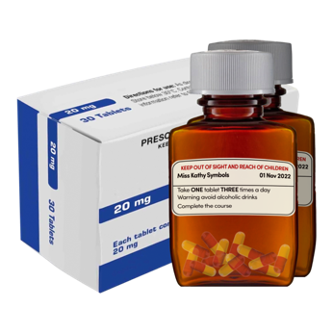
Reporting your RAT means you can get:
medical care
support.


You can report your RAT result on the My Health Record website at:

https://my.health.nz

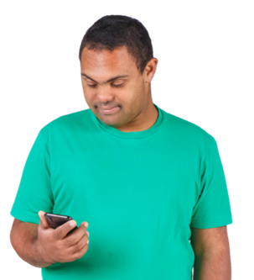
When you report a positive RAT you will get a text message from one of these numbers:
2328
2648
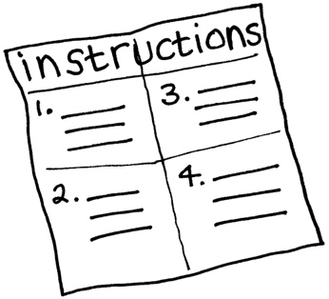
The message will have information about what to do next.

What to do if you have COVID-19

If you have COVID-19 you should to isolate for 5 days.

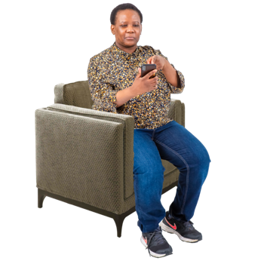
Isolate means you:
stay at home
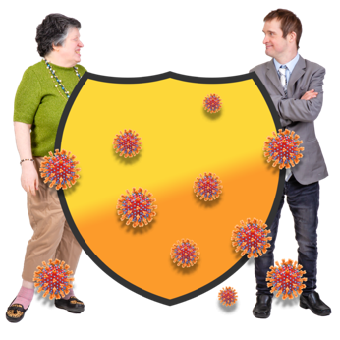
keep away from other people.

Isolating stops COVID-19 speading to other people.

The 5 days start the day after you:
have a positive COVID-19 test
start to feel unwell.

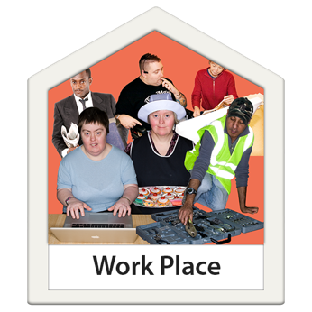
When you are isolating you should not go to:
work
school.

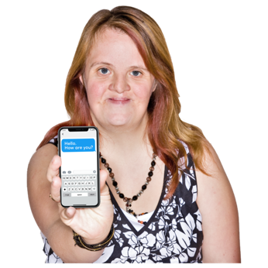
You can show the text you got when you reported your result to your employer / boss to tell them you need time off work.

You should isolate even if you do not feel very unwell.

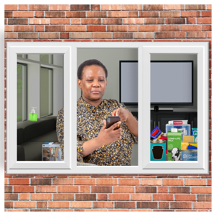
Your household contacts do not need to isolate.

Household contacts are the people you:
live with
spend a lot of time with.
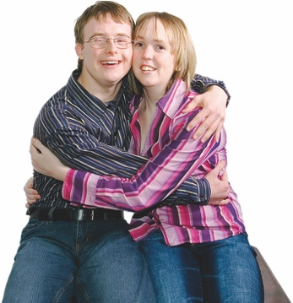

There is more information about household contacts in the part of this document called If you are a household contact.

How to isolate

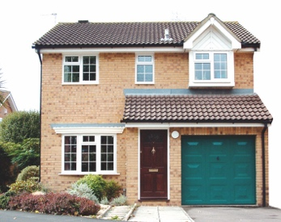
When you are isolating you should stay at home if you can.
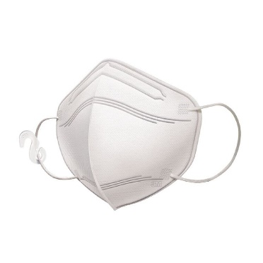

If you have to go somewhere while you are isolating you should wear a face mask.
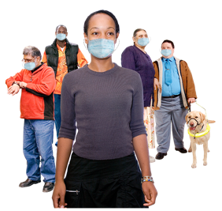

Wearing a face mask makes it harder to give COVID-19 to other people.

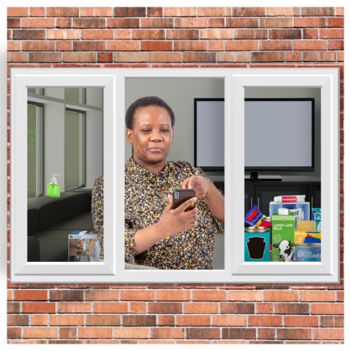
It is important to keep away from people who could get very sick from COVID-19.

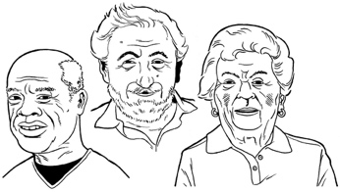
If you have COVID-19 you should not go to places like:
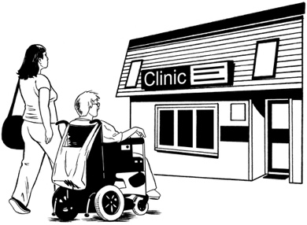
retirement homes / aged care facilities
healthcare providers.

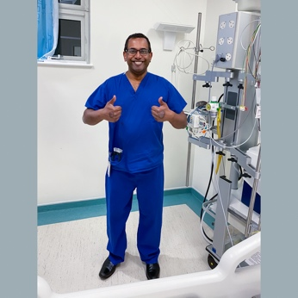
You can go to a doctor / hospital if you need medical care.

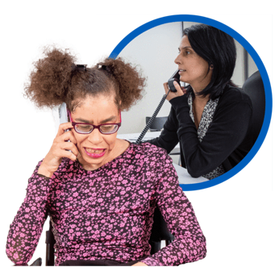
If you go to a doctor / hospital you should tell them you have COVID-19 straight away.

You can go outside to exercise.

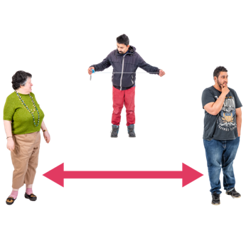
You should stay away from other people when you are exercising.

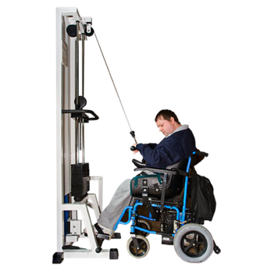
Do not go to indoor places where lots of people exercise like:
gyms
swimming pools.

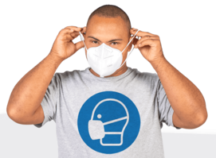
You can wear a face mask when you go outside to exercise.

You do not have to wear a face mask when you go outside to exercise.

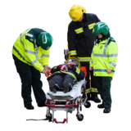
You should not do anything dangerous that might mean you:
get hurt
need someone to rescue you.
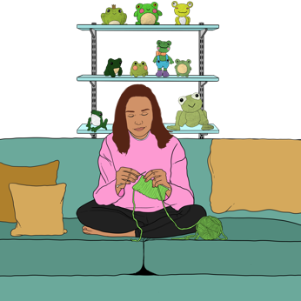
You can do some things to stop COVID-19 spreading to the people you live with.

Stay in a room by yourself as much as you can.

Wear a face mask when you need to be in the same room as other people.

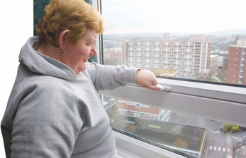
Open your windows so there is lots of fresh air inside.

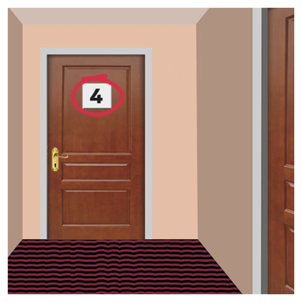
If you live in an apartment you need to take extra care not to spread COVID-19 to the people in your building.

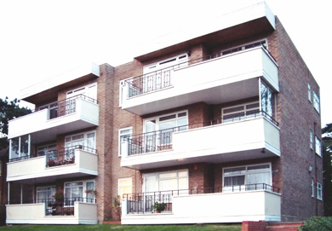
An apartment is a home that is part of a bigger building.

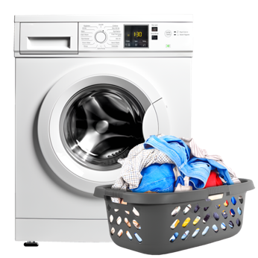
Your building might have shared areas like a:
laundry
gym
lounge / common room.

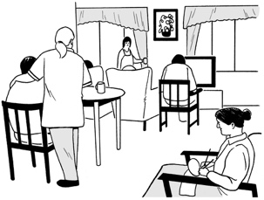
Try to stay away from shared areas if you have COVID-19.

If you have to go into a shared area you should:
wear a face mask
go when there are not very many people there
stay as far away from other people as you can.
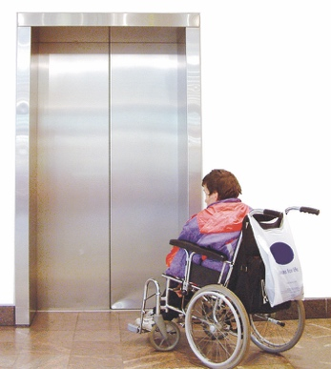

If there is a lift in your building you should only go in it by yourself if you can.

Isolating with tamariki / children
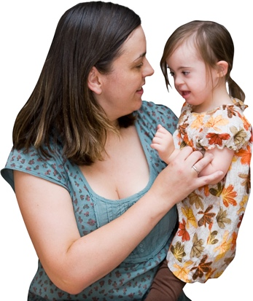

It can be hard to isolate when you have tamariki / children.

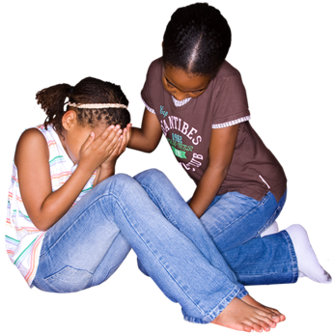
It can also be hard for tamariki / children to isolate when they have COVID-19.

There are some things you can do to stop COVID-19 spreading between:
you
your tamariki / children.

You should open your windows to let lots of fresh air in.

You should wear a face mask when you are in the same room as your tamariki / children.

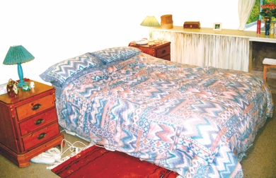
Try to have the person who has COVID-19 sleep in a different bedroom from people who do not have COVID-19.

Stay away from other people in your home as much as you can.

Leaving isolation
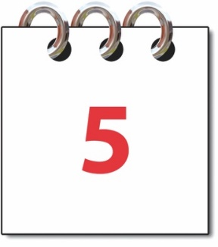

You can stop isolating:
after 5 days, and
you feel well again.

If you still feel unwell after 5 days you should keep isolating until you feel well again.

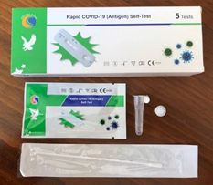
You do not need to do another RAT.

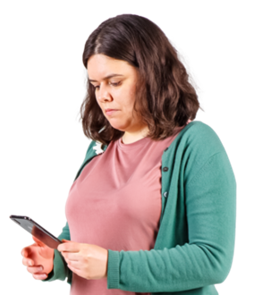
You might get a text message to say you can stop isolating.

You do not need to wait for the message before you stop isolating.
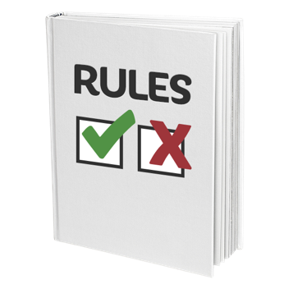
There might be different rules about going back to places like:
work

school

You should ask your work / school if it is okay to go back.

If you are a household contact

You are a household contact if you:
live with someone who has COVID-19
have spent 8 hours or more with someone who has COVID-19.


If you are away from home household contacts are people who share the same:
caravan / campervan
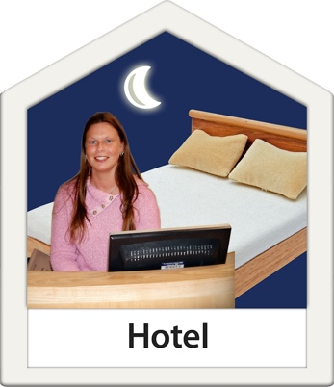
tent
bach / holiday home
hotel / motel room.

You do not need to isolate if you are a household contact.

Household contacts should stay home and do a RAT if they have symptoms.

Try to stay away from the person who has COVID-19.

If you test positive for COVID-19 you should isolate for 5 days.

You should wear a face mask if you go out while anyone in your home has COVID-19.

It is very important to wear a face mask if you are visiting people who could get very sick from COVID-19 like:
older people
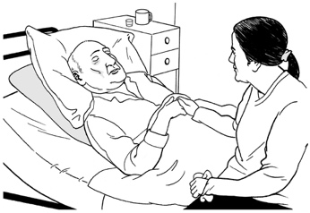
people who have medical conditions that make it hard for them to fight off diseases.

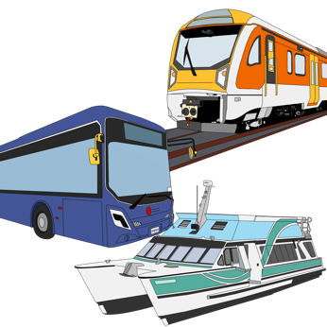
It is also important to wear a face mask in crowded places like:
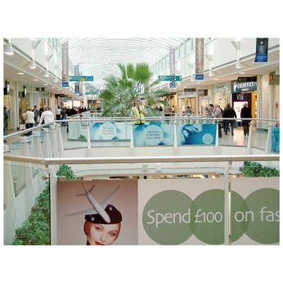
buses
trains
shops
You should check yourself for symptoms of COVID-19 for 10 days after someone in your home tests positive for COVID-19.

If you feel unwell you should:
stay home
do a COVID-19 test.

If you test positive for COVID-19 you should isolate for 5 days.

If you do not test positive for COVID-19 you should stay at home until you feel well again.

Where to get support

You can phone the COVID-19 disability helpline to get information about:
COVID-19 tests
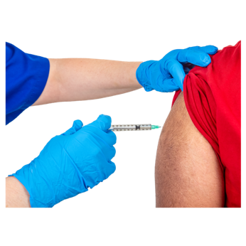
masks
COVID-19 vaccines
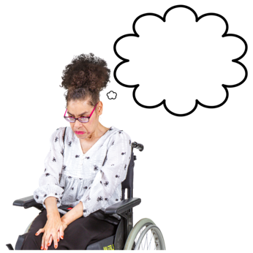
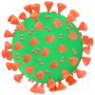
how to look after yourself when you have COVID-19
any other worries you have about COVID-19.

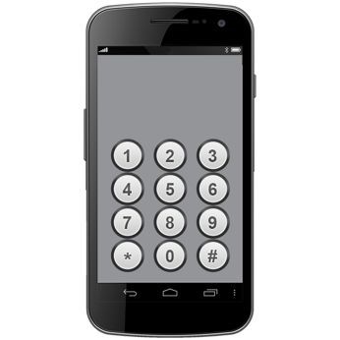
The phone number for the COVID-19 disability helpline is:

0800 11 12 13

You can also text the COVID-19 disability helpline on:

8988


If you find it hard to use the phone the New Zealand Relay service is for people who:

- are deaf / hard of hearing
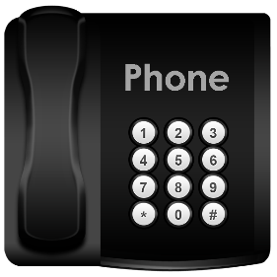
- are deafblind
- find it hard to talk.


You can find more about the New Zealand Relay service at this website:

www.nzrelay.co.nz/index

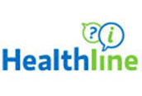
You can also call Healthline on:

0800 358 5453
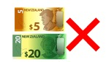

It does not cost money to call these numbers.

Where to find more information


The government website about COVID-19 is:

https://info.health.nz/COVID-19


You can use this website to find out more information about:
looking after yourself if you have COVID-19
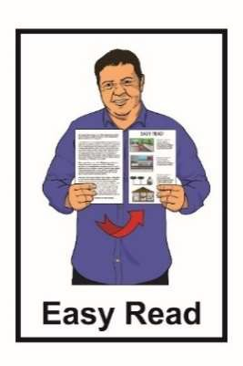
where to get support if you need it.

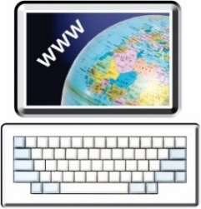
More information about COVID-19 is available in Easy Read on the COVID-19 website at:

https://info.health.nz/easy-read/

This information has been written by
Health New Zealand | Te Whatu Ora.


It has been translated into Easy Read by the Make it Easy Kia Māmā Mai service of People First New Zealand Ngā Tāngata Tuatahi.

The ideas in this document are not the ideas of People First New Zealand Ngā Tāngata Tuatahi.


Make it Easy uses images from:

- Changepeople.org


- Photosymbols.com

- SGC Image Works


- Huriana Kopeke-Te Aho
- T. Wood.

All images used in this Easy Read document are subject to copyright rules and cannot be used without permission.

