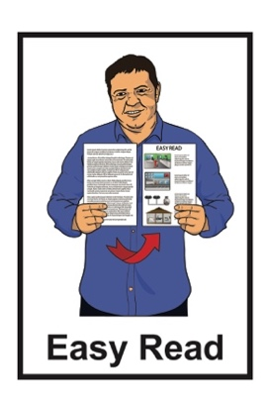

Testing for COVID-19
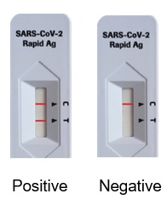

Updated: January 2024

What you will find in this document

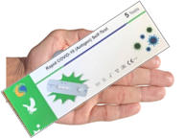
Page number:

What is in this document 3

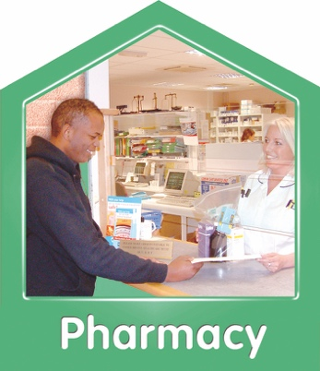
When to do a COVID-19 test 5

Where to get a COVID-19 test 10
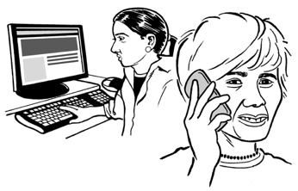

How to report a RAT result 13

What to do if you have
COVID-19 18

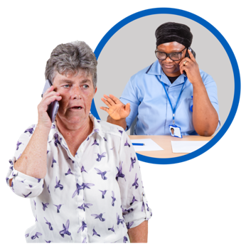
Page number:

Where to get support 21

Where to find more information 24

What is in this document

This document is about doing a test for COVID-19.

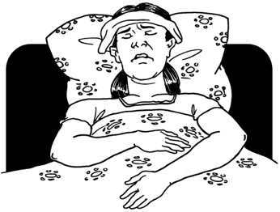
COVID-19 is a virus that can make people very ill.

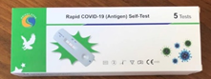
A COVID-19 test can tell you if you have COVID-19.

If the test is positive that means you have COVID-19.

If the test is negative that means you may not have COVID-19.

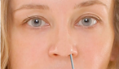
Most COVID-19 tests use a sample from your nose.

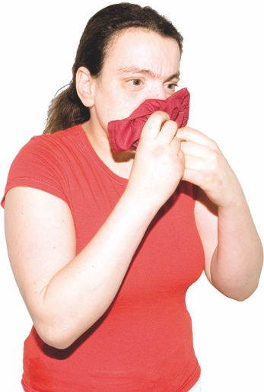
A sample is a bit of mucus from the back of your nose.

Mucus is what comes out of your nose when you blow it.

When to do a COVID-19 test

You should do a COVID-19 test if you have symptoms of:
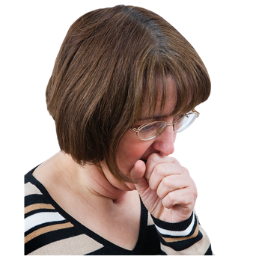
COVID-19
a cold
the flu.
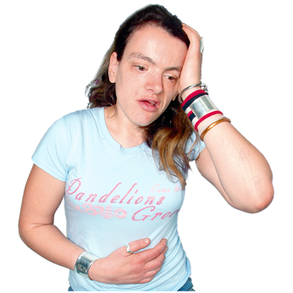

Symptoms means signs that you may have an illness.

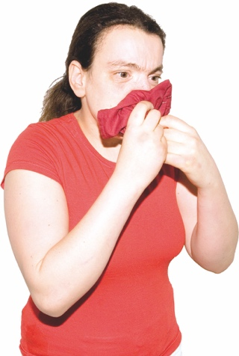
COVID-19 symptoms include things like:
a cough
sneezing and a runny nose
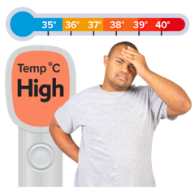
finding it hard to breathe.
high temperature of at least 38°C on a thermometer – this is when you would feel very hot
a sore throat
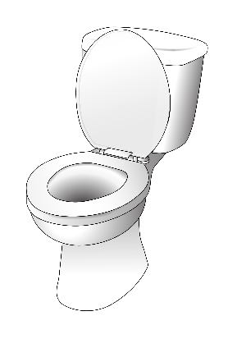
not being able to smell things for a little while
diarrhoea / runny poo
nausea / vomiting

Other COVID-19 symptoms are:
headache
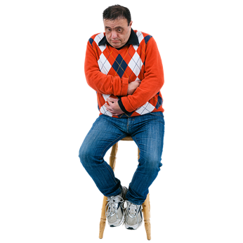
muscle pain or body aches
malaise — a general feeling of being unwell.

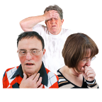
All these symptoms:
do not always mean you have COVID-19
can be symptoms of other illnesses like a cold or flu.

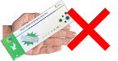
You might not need to do a test if it is only a short time since you last had COVID-19.

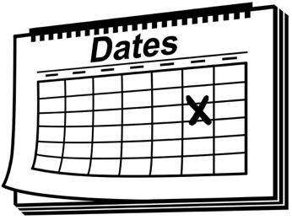
Count the days from when you:
had a positive COVID-19 test
first felt unwell.

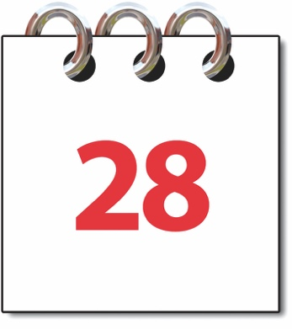
If it is less than 28 days since you had a positive test / felt unwell you do not need to do another COVID-19 test.

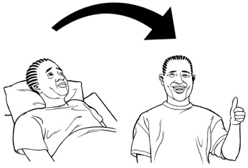
You should stay at home until you feel well again.

If it has been more than 28 days since you had COVID-19 you need to do a test.

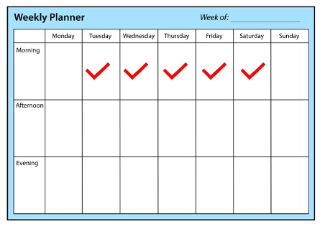
If someone you live with has COVID-19 you should do a COVID-19 test every day for 5 days.

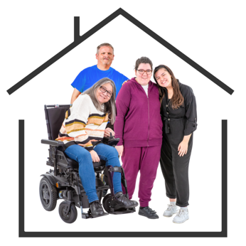
The people you live with are sometimes called household contacts.

Where to get a COVID-19 test

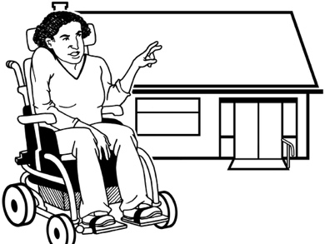
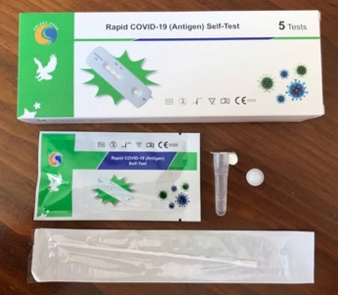
Most COVID-19 tests are RATs.

A RAT is a COVID-19 test you can do at home.

RATs are also called rapid antigen tests.

You can get RATs from:
COVID-19 testing centres
RAT collection sites
some pharmacies / chemists.

To find out where to get RATs go to this website:
https://tinyurl.com/5bshtjtj

The website is not in Easy Read
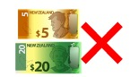

It does not cost money to get RATs.

You can go out to get RATs even if you are sick.

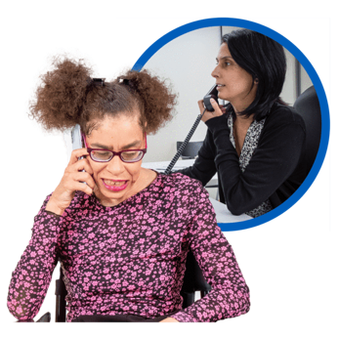
Some doctors also do COVID-19 tests.

You can phone your doctor to get advice about doing a COVID-19 test.

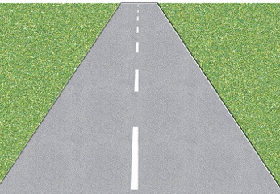
It can be hard for some people to get RATs because they:
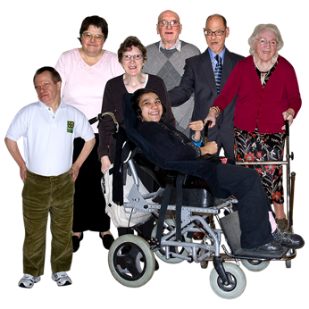
live a long way away from a collection centre
are disabled
have health problems.
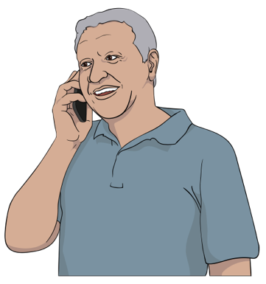

If it is hard for you to get RATs you can phone:

0800 222 479

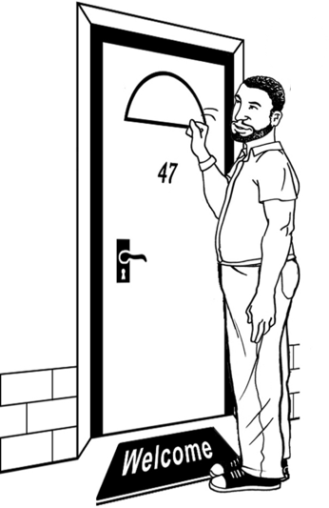
You might be able to:
have some RATs delivered to you.
get some other support.

How to report a RAT result

You should report what your RAT says if it is:
positve
negative.

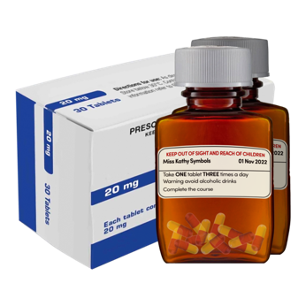
Reporting your RAT means you can get:
medical care
support.

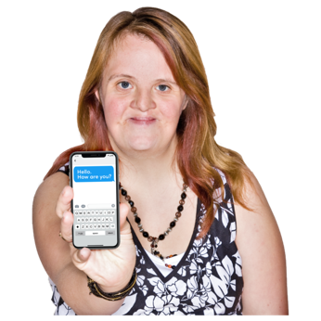
When you report a positive RAT you will get a text message from one of these numbers:
2328
2648
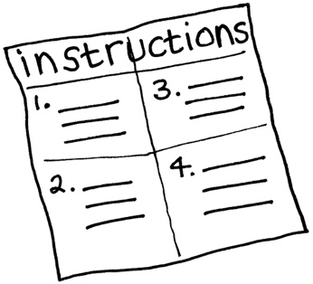

The message will tell you:
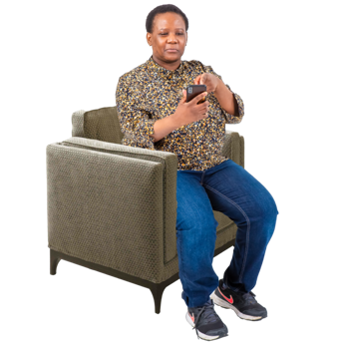
what to do next
if you need to isolate.

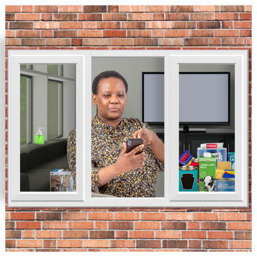
Isolate means you:
stay at home
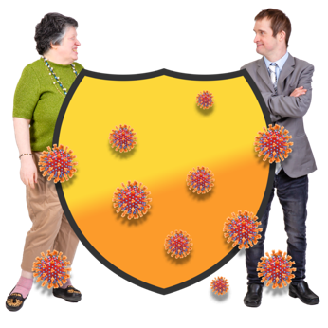
keep away from other people.

Isolating stops COVID-19 speading to other people.
You can report your RAT result on the My COVID Record website at:

https://mycovidrecord.health.nz

My COVID Record is not in Easy Read.

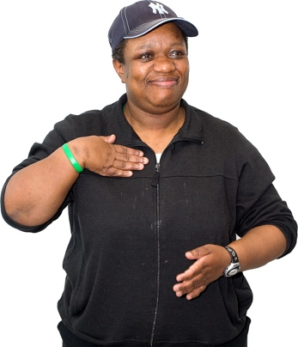
You can report a RAT for:
yourself
someone else.

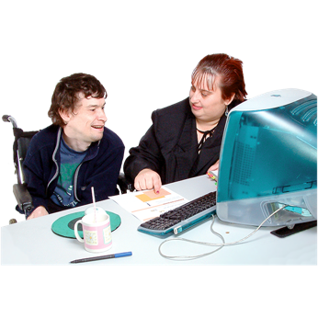
If you are reporting a RAT for someone else you will need their
NHI Number.

An NHI number is a number that tells health workers who you are.

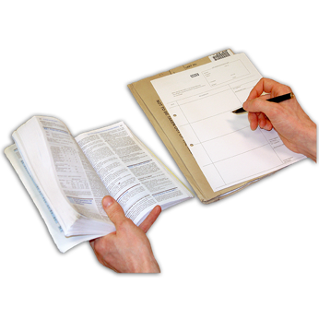
You can find your NHI number on:
a prescription from your doctor
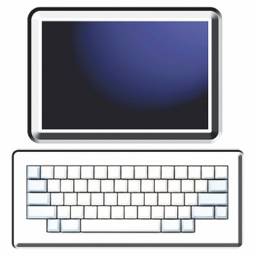
a hospital letter
the online patient portal for your doctor.

You can also report a RAT result over the phone on:

0800 222 487

Use the phone to report your RAT if you:
are having trouble with
My COVID Record
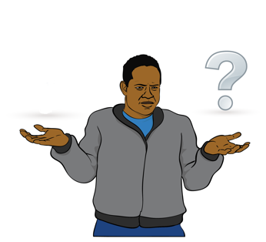
do not know the NHI number for the person whose RAT you are reporting.

What to do if you have COVID-19

If you have COVID-19 you should isolate for at least 5 days.

You should to keep isolating until you feel well again.

You should phone your doctor if you have a medical condition that could make COVID-19 worse like:
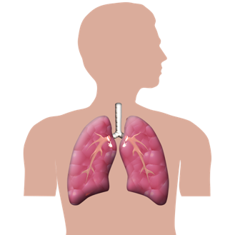
asthma
diabetes
heart disease.

You should also phone your doctor if:
you are feeling very ill.
your symptoms are getting a lot worse.

You can also phone Healthline on:
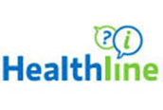
0800 358 5453

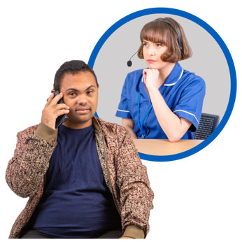
Healthline is a number you can call to get medical advice.

You can call Healthline at any time.

It does not cost money to call Healthline.

It is important to look after yourself when you have COVID-19.

Where to get support

You can phone the COVID-19 disability helpline to get information about:
COVID-19 tests
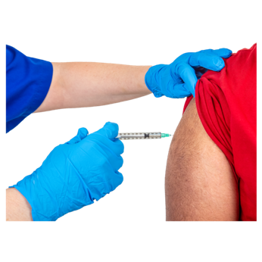
masks
COVID-19 vaccines
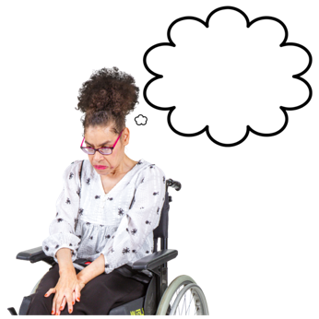
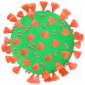
how to look after yourself when you have COVID-19
any other worries you have about COVID-19.

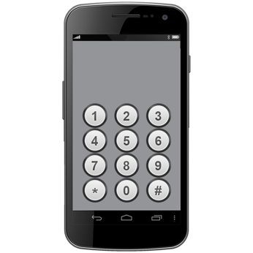
The phone number for the COVID-19 disability helpline is:

0800 11 12 13

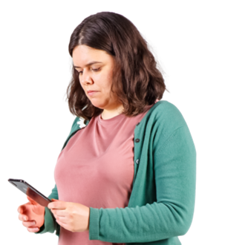
You can also text the COVID-19 disability helpline on:

8988

If you find it hard to use the phone the New Zealand Relay service is for people who:

- are deaf / hard of hearing
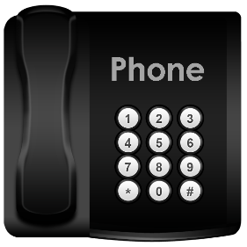
- are deafblind
- find it hard to talk.

You can find more about the New Zealand Relay service at this website:

www.nzrelay.co.nz/index

You can call Healthline on:

0800 358 5453

It does not cost money to call these numbers.

Where to find more information

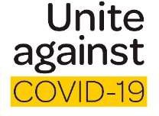
The government website about COVID-19 is:

https://covid19.govt.nz

You can use this website to find out more information about:
looking after yourself if you have COVID-19
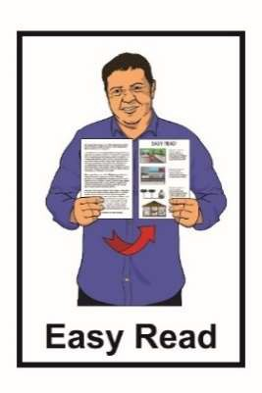
where to get support if you need it.

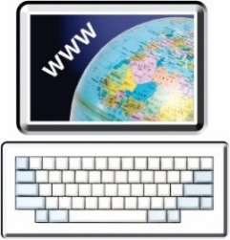
More information about COVID-19 is available in Easy Read on the COVID-19 website at:

https://covid19.govt.nz/easy-read
This information has been written by
Te Whatu Ora Health New Zealand.

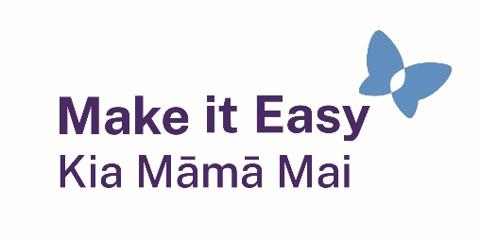
It has been translated into Easy Read by the Make it Easy Kia Māmā Mai service of People First New Zealand Ngā Tāngata Tuatahi.
The ideas in this document are not the ideas of People First New Zealand Ngā Tāngata Tuatahi.

Make it Easy uses images from:

- Changepeople.org

- Photosymbols.com

- SGC Image Works
- Huriana Kopeke-Te Aho
- T. Wood.
All images used in this Easy Read document are subject to copyright rules and cannot be used without permission.

