
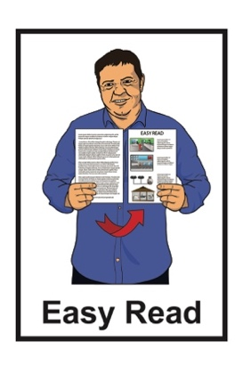

Information about the

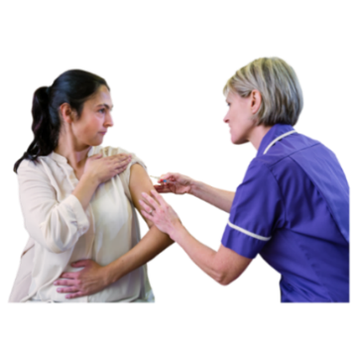
COVID-19 vaccine

Published: February 2024

What you will find in here

Page number:
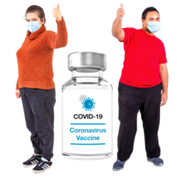

What is the COVID-19 vaccine? 2
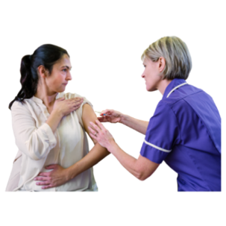

Who can get the vaccine? 4
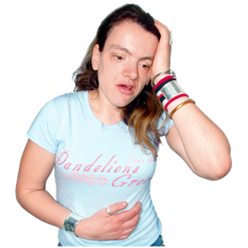

Feeling unwell after your vaccine 13
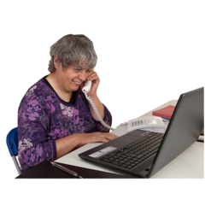

How to get a COVID-19 vaccine 16
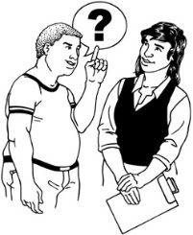

If you need support 20


Where to find more information 23

What is the COVID-19 vaccine?

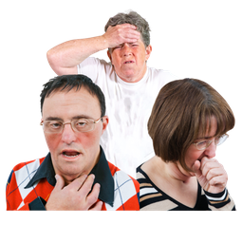
COVID-19 is a virus that can make people very sick.

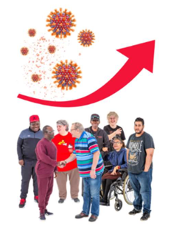
The COVID-19 vaccine can protect you from the virus.
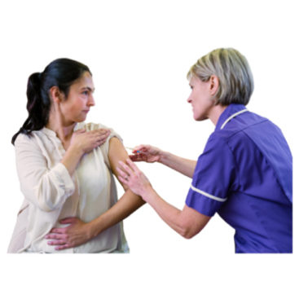

The COVID-19 vaccine helps your body to make antibodies.
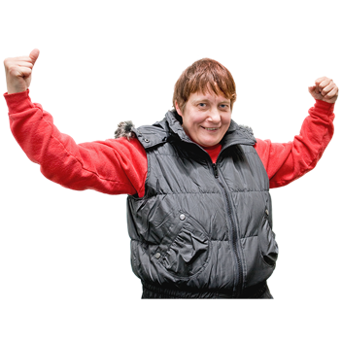

Antibodies help your body to fight
off illness like COVID-19.

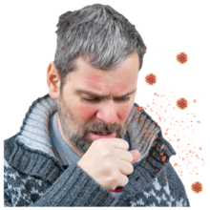
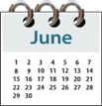
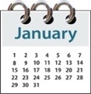

The number of antibodies you have in your body gets smaller over time.

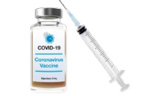
This means you may need to get another injection (also called an additional dose) of the vaccine.

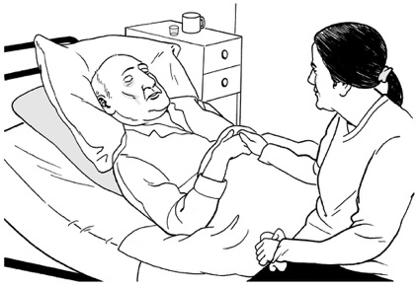
An additional dosewill lower your risk of:

getting very sick from COVID-19
ending up in hospital.

Who can get the vaccine?

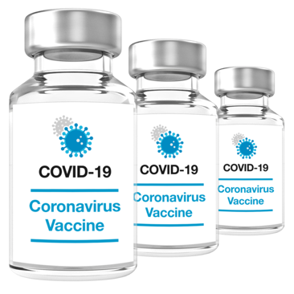
Everyone in Aotearoa New Zealand aged 5 years old or older can get a free COVID-19 vaccine.


Children aged 6 months to 4 years old can get a vaccine if they have a bigger risk of illness from COVID-19.

It does not matter what visa or citizenship you have.

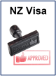
A visa is a document that lets you stay in Aotearoa New Zealand if you are from another country.


Citizenship of a country means you can get a passport for that country.


You are usually a citizen of the country you were born in.

There are 2 COVID-19 vaccines you can get in New Zealand.

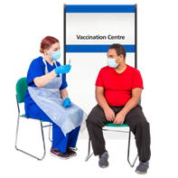
These vaccines are:
Pfizer
Novavax.

Both vaccines protect you from the COVID-19 virus.


COVID-19 vaccines are free.

This means they do not cost you any money.

If you are 30 years of age or over

If you are 30 years of age or over it does not matter how many doses you have had already.

You can have an additional dose if:
you have had your first 2 COVID-19 vaccinations
you have not had COVID-19 in the last 6 months
you have not had any other COVID-19 vaccine in the past 6 months.


If you are 16 to 29 years of age

Most people aged 16 to 29 can have 1 additional dose.

You can have an additional dose if:
you have had at least your first 2 COVID-19 vaccinations
you have not had COVID-19 in the last 6 months
you have not had any other COVID-19 vaccine in the past 6 months.

Some people aged 16 to 29 can have an extra additional dose including:
severely immunocompromised people
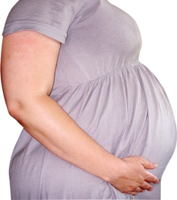
pregnant people
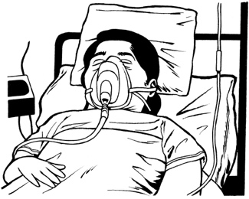
those who have a medical condition that makes them more likely to get very sick if they have COVID-19
disabled people with serious health needs.
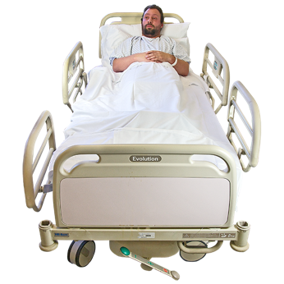
Immunocompromised means that your body finds it hard to fight off illness.

If you are 12 to 15 years old

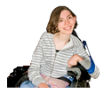
Children under 16 years old cannot get additional doses unless they are:
12 to 15
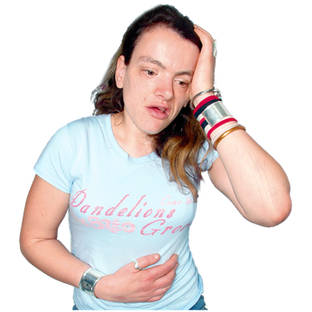
and
have a medical condition that makes them more likely to get very sick if they get COVID-19.

Talk to your healthcare provider about:
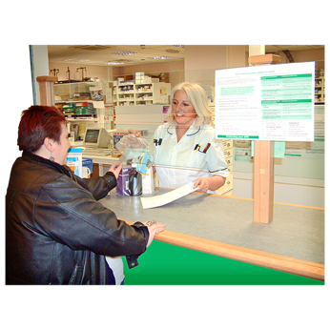
whether this is best for you
how to get a prescription for a booster vaccine.

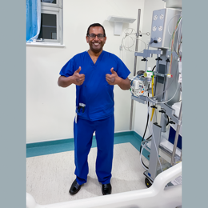
Your healthcare provider can be someone like a:
GP / family doctor
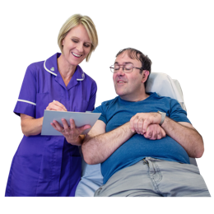
nurse.

Children under 12 years old

Children under the age of 12 cannot get an additional dose.

You can talk about the health of your child with your:
doctor
nurse
healthcare provider.

Children are much less likely to:
have a very bad illness
need to go to hospital if they get COVID-19.

Feeling unwell after your vaccine

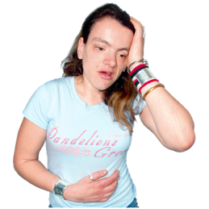
You might feel unwell in the days after getting your vaccine.

This is a sign that your body is learning to fight the virus.

Some of the things you might feel after getting your vaccine include:
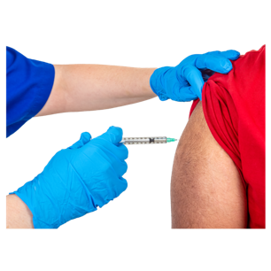
pain / swelling / redness where the needle went into your arm

tiredness
headaches
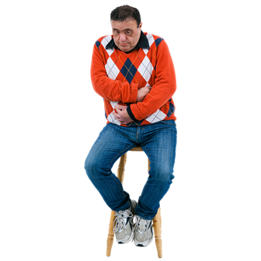
muscle pain
chills.

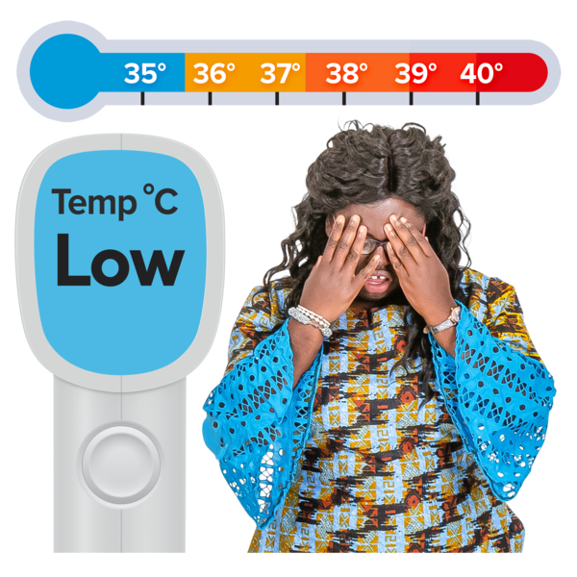
Chills are when your body feels very cold.

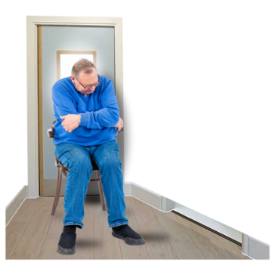
Other sorts of things you might feel after getting your booster include:
joint pain
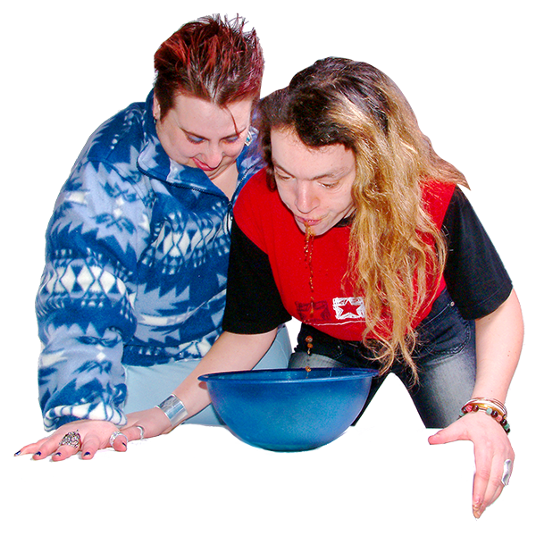
nausea / feeling sick
fever.

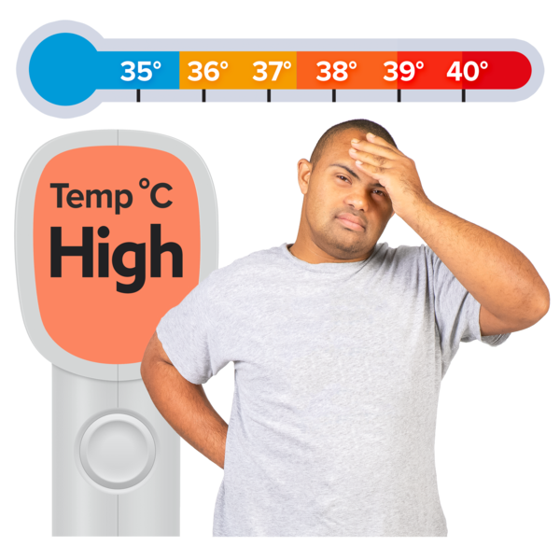
A fever:
is when your body gets very hot
can also give you a strong headache.

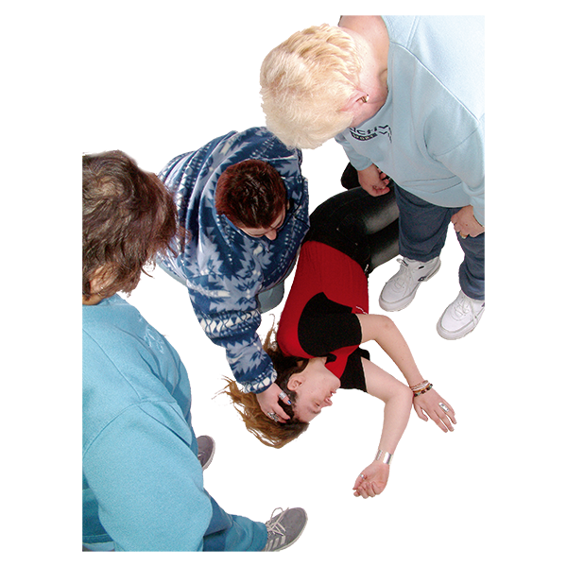
Some people might have a severe allergic reaction to the vaccine.

A severe allergic reaction is where your body gets very sick from the vaccine itself.

Severe allergic reactions from the vaccine do not happen often.

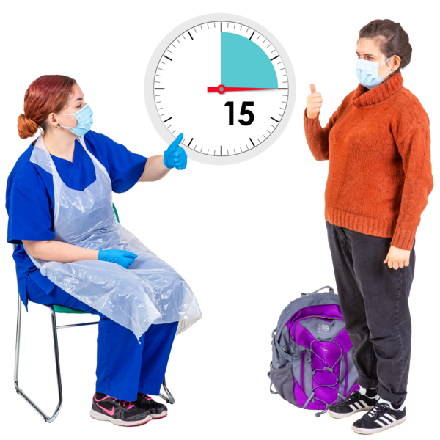
After getting your booster vaccine you have to wait for 15 minutes.

This is to make sure you do not have an allergic reaction.

How to get a COVID-19 vaccination


You can use the Book My Vaccine website to:
book a vaccine appointment
change your appointment.


Before you book check the appointment availability map on the website.


It can show you:
where vaccine places are
how soon you can get an appointment.

It can also show you which vaccine types are available.

You can book your COVID-19 vaccine online at:

www.BookMyVaccine.nz

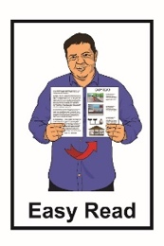
The information on this link may not be available in Easy Read.

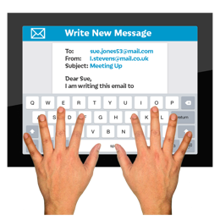
If you have problems booking or need to change your details email:

booking@bookmyvaccine.health.nz

You can also book by phoning the COVID-19 Vaccination Healthline.


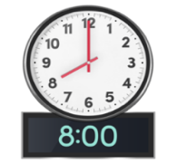
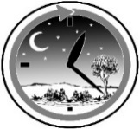
You can call the COVID-19 Vaccination Healthline:
8 am to 8 pm
7 days a week.

Call the COVID-19 Vaccination Healthline:

0800 28 29 26


You can ask for an interpreter if you need one.

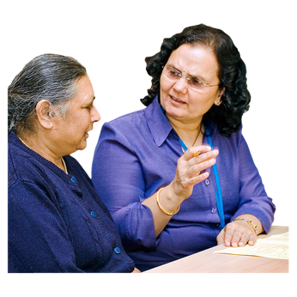
An interpreter is someone who makes it easy for another person to understand what you need.

They can also change what other people say for you to understand as well.
There are many places around Aotearoa New Zealand where you can get a COVID-19 vaccine without an appointment.

This is called a walk-in appointment.

To find a walk-in vaccine centre go here:

https://www.healthpoint.co.nz/covid-19-vaccination/

The information on the link above may not be available in Easy Read.

If you need support

The COVID-19 disability helpline can provide support or information about:
vaccines
face masks
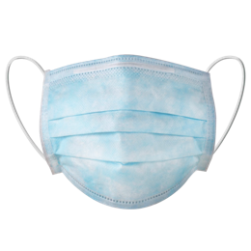
testing
managing COVID-19

any other health concerns you may have.

You can call the COVID-19 disability helpline on:
0800 11 12 13

It is free to call this number.

This means it does not cost any money.

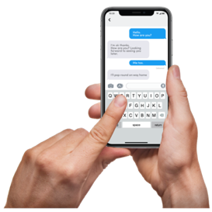
If you cannot call you can text:

8988

You can also call the Vaccination Healthline for advice on:

0800 28 29 26

You can call the Vaccination Healthline:
between 8 am – 8 pm
7 days a week.

It is free to call this number.

This means it does not cost any money.

Where to find more information


The government website about COVID-19 is:

https://info.health.nz/COVID-19

You can use this website to find out more information about:

- looking after yourself if you have COVID-19

- where to get support if you need it.


This information has been written by
Health New Zealand | Te Whatu Ora.


It has been translated into Easy Read by the Make it Easy Kia Māmā Mai service of People First New Zealand Ngā Tāngata Tuatahi.


The ideas in this document are not the ideas of People First New Zealand Ngā Tāngata Tuatahi.

Make it Easy uses images from:


- Changepeople.org


            - Photosymbols.com

- SGC Image Works
- Huriana Kopeke-Te Aho

- T. Wood.

All images used in this Easy Read document are subject to copyright rules and cannot be used without permission.

